A FIELD PROJECT REPORT ON
“JOB PORTAL’’
Submitted in partial fulfilment of the requirements for the award of the degree

BACHELOR OF TECHNOLOGY
in

(COMPUTER SCIENCE ENGINEERING)

Submitted by:-

Y.RAVITEJA  G.RUKESH  V.DIVYA SRI  P.LOKESH |  | (241FA04865)  (241FA0C75)  (241FA04C79)  (241FA0D14)
Under the Guidance of
Guide Name
Designation


Department of Computer Science and Engineering
School of Computing and Informatics
Vignan’s Foundation for Science, Technology and Research (Deemed to be University) Vadlamudi, Guntur, Andhra Pradesh-522213, India.April – 2026

CERTIFICATE

- This is to certify that the field project entitled “JOB PORTAL” being submitted by (Y.RAVITEJA & 241FA04865), (G.RUKESH & 241FA0C75), (V.DIVYA SRI & 231FA04C79), and (P.LOKES & 241FA04D14) in partial fulfilment of Bachelor of Technology in the Department of COMPUTER SCIENCE ENGINEERING, Vignan’s Foundation For Science Technology & Research (Deemed to be University), Vadlamudi, Guntur District, Andhra Pradesh, India, is a bonafide work carried out by them under my guidance and supervision.

Guide

Project Review Committee | Head of the Department


DECLARATION
We hereby declare that our project work described in the field project titled “ONLINE EXAMINATION” which is being submitted by us for the partial fulfilment in the department of COMPUTER SCIENCE ENGINEERING, Vignan’s Foundation for Science, Technology and Research (Deemed to be University), Vadlamudi, Guntur, Andhra Pradesh, and the result of investigations are carried out by us under the guidance of (Name of the Guide)

Y.Raviteja 241FA04865 signature
G.Rukesh 241FA04C75 signature
V.Divya sri 241FA04C79 signature
P.Lokesh 241FA04D14 signature

 |  |  | 
 |  |  | 5
 | 1.1 |  | 5
 | 1.2 |  | 5
 | 1.3 |  | 6
 | 1.4 |  | 7-8
 |  |  | 8-9
 | 2.1 |  | 9-10
 | 2.2 |  | 10-12
 |  |  | 12
 | 3.1 |  | 12-13
 |  |  | 13-15
 |  |  | 15
 | 4.1 |  | 14-31
 |  |  | 31-32
 |  |  | 33-33
 | 5.1 |  | 34
 |  |  | 36-37
 | 6.1 | References | 38
TABLE OF CONTENTS

“JOB POTRAL”

- Introduction
1.1 Problem Definition:- The traditional job application and recruitment process has long been the backbone of hiring in organizations. However, it comes with several critical challenges that make it inefficient in modern-day recruitment environments. Some of these challenges include:
- Manual Effort and Time Consumption: Managing job postings, receiving applications, screening resumes, and scheduling interviews manually involves a significant amount of labor and time.
- Errors in Candidate Selection: Due to human involvement, there is always a risk of bias and mistakes in candidate evaluation, leading to unfair hiring decisions.
- Security Issues: Paper-based and unsecured online application systems are vulnerable to data breaches, unauthorized access, and fraudulent activities.
- Limited Accessibility: In many cases, job seekers must visit company websites or physical locations to apply for jobs, which can be inconvenient for those with limited access to technology or residing in remote areas.
- Delayed Hiring Process: Since applications are screened and evaluated manually, it can take days or even weeks to make hiring decisions, causing delays in filling open positions.
Need for an Online Job Portal To overcome these challenges, an automated, secure, and efficient job portal is required. The online job portal aims to:
- Reduce manual workload by automating the job posting and application process.
- Provide instant candidate matching with accurate ranking.
- Enhance security to prevent data breaches and unauthorized access.
- Support job seekers with low internet connectivity by optimizing performance.
- Ensure fair evaluation with minimal human intervention.
The goal is to streamline the recruitment process, ensuring that it is efficient, accurate, and accessible to all job seekers.
1.2 Existing System :-Several online job portals exist today, but they are often limited in functionality, security, and accessibility. Some common drawbacks of existing systems include:
- Dependency on High-Speed Internet
- Most online job portals require a stable and high-speed internet connection to function properly.
- Job seekers in rural or low-bandwidth areas struggle to access these systems, leading to application failure due to network disruptions.
- Limited Access Control and Role Management
- In many platforms, only a single administrator is allowed to manage job postings.
- This creates bottlenecks in job scheduling and limits flexibility in large organizations.
- Weak Security Measures
- Many existing systems lack robust authentication mechanisms, making them vulnerable to unauthorized logins.
- Poor encryption techniques lead to data leaks, exposing sensitive job seeker information.
- Absence of Automated Candidate Matching
- Some platforms lack automated candidate matching, requiring manual screening.
- Job seekers do not receive instant feedback, delaying hiring decisions.
- No Mechanism for Job Seeker Feedback
- Many platforms do not include a feedback mechanism, preventing job seekers from reporting issues or suggesting improvements.
The existing solutions fail to fully address the growing need for a scalable, secure, and feature-rich online job portal.
1.3 Proposed System :-To address the limitations of the existing systems, this project introduces an advanced Online Job Portal with the following features:
- Multi-User Role Access
The system supports three main roles:
- Admin: Manages employer accounts, job seeker data, and feedback submissions.
- Employer: Posts job openings, evaluates applications, and reviews candidate performance.
- Job Seeker: Applies for jobs, views past applications, and provides feedback.
- Security & Authentication
- Encrypted user credentials ensure secure logins.
- Role-based access control (RBAC) prevents unauthorized access to job postings.
- One-time application restriction prevents job seekers from reapplying for the same job unless permitted by the employer.
- Automated Job Management
- Employers can add/remove/edit job postings dynamically.
- The system automatically matches candidates based on qualifications.
- Instant feedback is generated with candidate ranking.
- Optimized for Low Internet Connectivity
- The platform is lightweight and efficient, ensuring that users with slow internet connections can still access and apply for jobs smoothly.
- Job Seeker Feedback System
- Job seekers can submit feedback about job postings and report issues.
- Admins can review and act on suggestions for system improvement
1.4Literature Review
Web-based job portals have become essential platforms in connecting job seekers with recruiters. As user interactivity and data sensitivity have grown, the significance of secure login validation and efficient session management has increased significantly. The literature reveals several key areas of research and development related to these topics:
1. User Authentication Mechanisms
Various studies emphasize the importance of robust user authentication in web applications to ensure data privacy and access control. Traditional login systems utilizing HTML forms with client-side JavaScript validation are common, but these must be reinforced with server-side authentication to prevent unauthorized access and SQL injection attacks (Kaur & Chana, 2016). Modern approaches incorporate two-factor authentication (2FA), CAPTCHA verification, and encrypted password storage.
2. Session Handling Techniques
Session management is vital in maintaining a user’s state across multiple pages in a stateless protocol like HTTP. Literature highlights techniques such as session cookies, tokens (e.g., JWT), and localStorage mechanisms for persistent login (Singh et al., 2018). While cookies are server-controlled and vulnerable to cross-site scripting (XSS), localStorage provides a simpler client-side alternative for basic session persistence, especially in front-end-only applications.
3. Security Concerns in Web Portals
Studies by OWASP (Open Web Application Security Project) underline the top vulnerabilities in web applications, including broken authentication, session hijacking, and cross-site request forgery (CSRF). Implementing secure HTTPS protocols, input sanitization, and secure session timeout policies are recommended practices (OWASP, 2021).
4. User Interface and Experience
In a job portal environment, usability is equally critical. Research supports that intuitive navigation, responsive layouts, and clear feedback mechanisms (like toggling content and dynamic menus) greatly enhance user experience (Nielsen, 2017). The use of animated transitions and collapsible content sections, like the toggleHomeContent() function in this project, aligns with current UI trends aimed at improving interactivity.
5. Real-World Implementations
Several enterprise-level job portals such as LinkedIn, Naukri.com, and Indeed utilize a combination of client-server authentication models and RESTful session APIs to manage millions of users. They also leverage modern frameworks such as React.js, Angular, and backend technologies like Node.js or Spring Boot for full-stack session handling and scalability (Sharma & Kumar, 2019).
2.System Requirements
The TCS Job Portal is a web-based application developed using HTML, CSS, and JavaScript for the front-end. The following system requirements are categorized into hardware and software components necessary for development and deployment.
- Server-Side Requirements (For Hosting the System)
The server is responsible for handling database queries, user authentication, and exam processing.
Component | Minimum Requirement | Recommended Requirement
Processor | Intel Core i3 (or equivalent) | Intel Core i5/i7 (or higher)
RAM | 4GB | 8GB or more
Storage | 20GB HDD (for database & files) | 50GB SSD (for better performance)
Network | Minimum 1 Mbps | 10 Mbps (for smooth performance)
Operating System | Windows Server / Linux | Ubuntu 20.04 LTS / Windows Server

2.1Client-Side Requirements (For Candidate and Admins)
Since the system is web-based, it runs without requiring any high-end hardware. Users need only a basic computer or smartphone with an internet connection.

Component | Minimum Requirement | Recommended Requirement
Processor | Any Dual-Core CPU (1.6 GHz) | Intel Core i3 or higher
RAM | 2GB | 4GB or more
Storage | At least 500MB free space | 1GB free space
Display | 1024x768 resolution | 1920x1080 resolution
Internet | Minimum 512 Kbps | 2 Mbps or more

2.1.2 Software Requirements
The system requires a server setup and a web browser for clients.
Software Component | Required Version
Operating System | Windows, Linux (Ubuntu, CentOS)
Web Server | Apache (XAMPP/WAMP)
Database | MySQL 5.7 or higher
Programming Languages | PHP 7.4+, JavaScript, HTML5, CSS3
Backend Framework | PHP with MySQL

- Server-Side Software Requirements
- Client-Side Software Requirements
Software Component | Required Version
Web Browser | Chrome, Firefox, Edge (latest)
JavaScript Enabled | Required
Device Compatibility | Desktop, Laptop, Tablet, Mobile

2.2 job Requirements Specification (JRS)

These define the specific operations the system must perform.

1. User Authentication and Authorization
- Secure login/logout system with role-based access (Admin, Employer, Job Seeker)
- Password encryption to protect user credentials.
- Automatic session timeout for inactive users.

2. Job Management
- Employers can create, edit, and delete job postings.

- Job seekers can apply for jobs and view their application status.

- Automated matching of job seekers with job openings based on qualifications.

3. Application Evaluation and Processing
- Employers can evaluate and rank job seeker applications.

- Job seekers receive instant feedback on their application status.

- Ranking system to compare job seeker performance.

4. Feedback and Communication

- Job seekers can submit feedback after applying for a job.

- Employers can review feedback and improve job postings.

- Admins manage and monitor system feedback.

5. Security Features

- Encrypted database storage to prevent data leaks.

- IP logging and access control for secure job application sessions.

- Restrict multiple logins from different locations to prevent fraudulent activities.

2.2.2 Non-Functional Requirements

These define the quality attributes of the system, such as security, performance, and scalability.

1. Security Requirements

- Secure Authentication: Users must log in using encrypted passwords.

- Data Encryption: All user information is stored securely in MySQL.

- Access Control: Role-based access ensures that users cannot perform unauthorized actions.

2. Performance Requirements

- Response Time: System should load job postings within 3 seconds on a stable internet connection.

- Concurrent Users: Should support at least 500 job seekers applying for jobs simultaneously.

- Application Processing: The system should process job applications and generate feedback instantly.

3. Scalability Requirements

- The system should be able to handle a growing number of users without performance degradation.

- Database optimization should ensure smooth operations as job posting data grows.

4. Availability Requirements

- The system should have 99.9% uptime, ensuring minimal downtime for job seekers and employers.

- Should include backup mechanisms to prevent data loss.

3. System Design

- The System Design phase outlines the architecture, structure, and interactions between different components of the Online Job Portal.

- This section details the system modules and provides an overview of the Unified Modeling Language (UML) diagrams, which visually represent how the system functions.

3.1 Modules of System
The Online Job Portal consists of multiple interconnected modules, each handling a specific function.
The major modules are:
1. User Management Module
This module is responsible for user registration, login authentication, and role-based access control.
Admin: Can manage all users (Employers and Job Seekers).
Employers: Can create job postings and manage applications.
Job Seekers: Can apply for jobs and view their application status.
2. Job Management Module
Handles the creation, management, and execution of online job postings.
Employers create and schedule job postings.
Job seekers apply for jobs based on availability.
The system automatically matches job seekers with job openings.
3. Application Evaluation Module

- Processes the applications submitted by job seekers.

- Employers evaluate and rank job seeker applications.

- Instant feedback is generated with application status.

4. Feedback and Report Generation Module

- Manages job seeker feedback, application history, and system reports.

- Job seekers can provide feedback on job postings.

- Employers and admins can generate performance reports.

5. Security and Access Control Module

- Ensures secure authentication and prevents unauthorized access.

- Role-based access: Job seekers, employers, and admins have different permissions.

- One-time login restriction: Prevents multiple logins from different devices.

- Data encryption and backup management for system security.

3.2 UML Diagrams

UML diagrams provide a visual representation of system functionality.

The key diagrams used in the system design are:

1. Use Case Diagram
Illustrates the interactions between users (Admin, Employer, and Job Seeker) and the system.

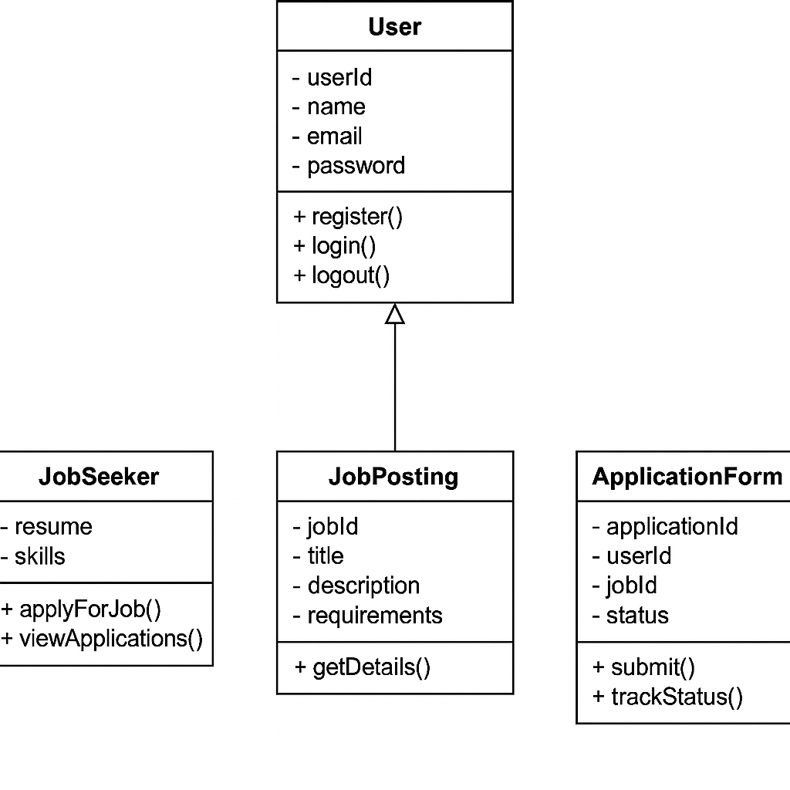

Actors:

Admin: Manages users, job postings, and system settings.

Employer: Creates job postings, evaluates applications, and views reports.

Job Seeker: Applies for jobs, views application status, and provides feedback.

Use Cases:

- User Authentication (Login/Logout)

- Job Posting Creation and Management

- Application Submission and Evaluation

- Result Processing and Ranking

- Feedback Submission
- Implementation
The Implementation phase involves the development and deployment of the Online Examination System based on the system design. This section covers the sample code for core functionalities and the test cases used to validate the system’s correctness, performance, and security.

4.1 Sample Code
Here, we provide sample code snippets for key functionalities, including user authentication, exam creation, and answer evaluation.
1. User Authentication (Login System in PHP)
This script validates user login and manages session handling.
<!DOCTYPE html>
<html>
<head>
<title>TCS Job Portal</title>
<style>
body{
font-family:Arial;
background:#f4f4f4;
text-align:center;
margin:0;
}
nav{
background:#007bff;
padding:15px;
}
nav a{
color:white;
text-decoration:none;
font-size:20px;
}
#content{
display:none;
background:white;
width:70%;
margin:20px auto;
padding:20px;
border-radius:10px;
box-shadow:0 0 10px gray;
}
</style>
</head>
<body>

<nav>
<a href="#" onclick="showContent()">Home</a>
</nav>

<div id="content">
<h2>TCS Job Portal</h2>
<p>Welcome to Tata Consultancy Services Job Portal.</p>

<h3>Features</h3>
<ul>
<li>Job Search</li>
<li>Resume Upload</li>
<li>Application Tracking</li>
</ul>

<h3>Company Details</h3>
<p>Founded: 1968</p>
<p>Headquarters: Mumbai, India</p>
</div>

<script>
function showContent(){
let x=document.getElementById("content");
if(x.style.display=="block")
x.style.display="none";
else
x.style.display="block";
}
</script>

</body>
</html>
About US:- <!DOCTYPE html>
<html>
<head>
<title>TCS Job Portal</title>
<style>
body{
font-family:Arial;
text-align:center;
background:url('https://c8.alamy.com/comp/2ATRYG8/job-vacancy-label-job-vacancyround-band-sign-job-vacancy-stamp-2ATRYG8.jpg');
background-size:cover;
}
nav{
background:#333;
padding:15px;
}
nav a{
color:white;
text-decoration:none;
font-size:20px;
}
#about{
background:white;
width:70%;
margin:30px auto;
padding:20px;
border-radius:10px;
}
</style>
</head>
<body>

<nav>
<a href="#">About Us</a>
</nav>

<div id="about">
<h2>TCS Job Portal</h2>
<p>Welcome to our Job Portal.</p>

<h3>Features</h3>
<ul>
<li>Job Listings</li>
<li>Resume Upload</li>
<li>Application Tracking</li>
</ul>

<h3>How to Apply</h3>
<ol>
<li>Register</li>
<li>Search Jobs</li>
<li>Apply</li>
</ol>

<p><b>Website:</b> www.tcs.com</p>
</div>

</body>
</html>

Home:-
Job Applications:-
<!DOCTYPE html>
<html>
<head>
<title>TCS Job Portal</title>
<style>
body{
font-family:Arial;
margin:0;
text-align:center;
background:url('https://c8.alamy.com/comp/2ATRYG8/job-vacancy-label-job-vacancyround-band-sign-job-vacancy-stamp-2ATRYG8.jpg');
background-size:cover;
}
nav{
background:#007bff;
padding:15px;
}
nav a{
color:white;
text-decoration:none;
font-size:20px;
}
#home{
display:none;
background:white;
width:75%;
margin:30px auto;
padding:20px;
border-radius:10px;
}
</style>
</head>
<body>

<nav>
<a href="#" onclick="showHome()">Home</a>
</nav>

<div id="home">
<h2>TCS Job Portal</h2>
<p>Welcome to Tata Consultancy Services.</p>

<h3>Features</h3>
<ul>
<li>Job Search</li>
<li>Resume Upload</li>
<li>Application Tracking</li>
</ul>

<h3>How It Works</h3>
<ol>
<li>Register</li>
<li>Apply</li>
<li>Get Hired</li>
</ol>

<p><b>Website:</b> www.tcs.com</p>
</div>

<script>
function showHome(){
let x=document.getElementById("home");
if(x.style.display=="block")
x.style.display="none";
else
x.style.display="block";
}
</script>

</body>
</html>
Software Developer:-
<!DOCTYPE html>
<html>
<head>
<title>Job Application</title>
<style>
body{
font-family:Arial;
background:url('https://c8.alamy.com/comp/2ATRYG8/job-vacancy-label-job-vacancyround-band-sign-job-vacancy-stamp-2ATRYG8.jpg');
background-size:cover;
display:flex;
justify-content:center;
align-items:center;
height:100vh;
}
#form{
background:white;
padding:20px;
width:300px;
border-radius:10px;
}
input{
width:100%;
padding:8px;
margin:8px 0;
}
button{
width:100%;
padding:10px;
background:blue;
color:white;
border:none;
}
</style>
</head>
<body>

<div id="form">
<h2>Software Developer</h2>

<input type="text" id="name" placeholder="Name">
<input type="email" id="email" placeholder="Email">
<input type="text" id="father" placeholder="Father Name">
<input type="number" id="phone" placeholder="Phone">
<input type="file">

<button onclick="apply()">Submit</button>

<p id="msg"></p>
</div>

<script>
function apply(){
document.getElementById("msg").innerHTML=
"Application Submitted Successfully";
}
</script>

</body>
</html>
Front-End Engineer:-
<!DOCTYPE html>
<html>
<head>
<title>Job Portal</title>
<style>
body{
font-family:Arial;
background:url('https://c8.alamy.com/comp/2ATRYG8/job-vacancy-label-job-vacancyround-band-sign-job-vacancy-stamp-2ATRYG8.jpg');
background-size:cover;
display:flex;
justify-content:center;
align-items:center;
height:100vh;
}
#app{
background:white;
padding:20px;
width:300px;
border-radius:10px;
}
input{
width:100%;
padding:8px;
margin:8px 0;
}
button{
width:100%;
padding:10px;
background:blue;
color:white;
border:none;
}
</style>
</head>
<body>

<div id="app">
<h2>Front-End Engineer</h2>

<input type="text" placeholder="Name">
<input type="email" placeholder="Email">
<input type="text" placeholder="Father Name">
<input type="number" placeholder="Phone">
<input type="file">

<button onclick="apply()">Submit</button>

<p id="msg"></p>
</div>

<script>
function apply(){
document.getElementById("msg").innerHTML=
"Application Submitted Successfully";
}
</script>

</body>
</html>

Data Analyst:-
<!DOCTYPE html>
<html>
<head>
<title>Job Application</title>
<style>
body{
font-family:Arial;
background:url('https://c8.alamy.com/comp/2ATRYG8/job-vacancy-label-job-vacancyround-band-sign-job-vacancy-stamp-2ATRYG8.jpg');
background-size:cover;
display:flex;
justify-content:center;
align-items:center;
height:100vh;
}
#app{
background:white;
padding:20px;
width:300px;
border-radius:10px;
}
input{
width:100%;
padding:8px;
margin:8px 0;
}
button{
width:100%;
padding:10px;
background:blue;
color:white;
border:none;
}
</style>
</head>
<body>

<div id="app">
<h2>Data Analyst</h2>

<input type="text" placeholder="Name">
<input type="email" placeholder="Email">
<input type="text" placeholder="Father Name">
<input type="number" placeholder="Phone">
<input type="file">

<button onclick="apply()">Submit</button>

<p id="msg"></p>
</div>

<script>
function apply(){
document.getElementById("msg").innerHTML=
"Application Submitted Successfully";
}
</script>

</body>
</html>

4.2 Test Cases
To ensure the reliability and efficiency of the job application System, multiple test cases are executed across different functionalities.
- User Authentication Testing
To ensure the reliability and efficiency of the job application system, multiple test cases are executed across different functionalities.

Test Cases
The following test cases are performed:

1. User Registration: Test that users can successfully register and create an account.
2. Job Application: Test that job seekers can apply for jobs and upload their resumes.
3. Application Tracking: Test that job seekers can track the status of their applications.
4. Employer Dashboard: Test that employers can post job openings and manage applications.
5. Search Functionality: Test that job seekers can search for jobs by keyword, location, and category.
6. Filtering and Sorting: Test that job seekers can filter and sort job listings by relevance, date posted, and salary.
7. Error Handling: Test that the system handles errors and exceptions correctly, such as invalid user input or database connectivity issues.
8. Security: Test that the system ensures the security and integrity of user data, including passwords and resumes.
9. Performance: Test that the system performs well under heavy loads and stress testing.

Testing Tools and Methodologies
The following testing tools and methodologies are used:

1. Unit Testing: Unit tests are written to ensure that individual components of the system function correctly.
2. Integration Testing: Integration tests are performed to ensure that different components of the system work together seamlessly.
3. System Testing: System tests are conducted to ensure that the entire system functions as expected.
4. Acceptance Testing: Acceptance tests are performed to ensure that the system meets the requirements and expectations of stakeholders.

Test Environment
The test environment is set up to mimic the production environment as closely as possible. This includes:

1. Hardware: The test environment uses the same hardware configuration as the production environment.
2. Software: The test environment uses the same software configuration

5.Results

Initial View (Before Clicking "Home")
- A clean navigation bar at the top with a “Home” button centered.
- A background color of light grey (#f4f4f4).
- The main content area (#home-content) is hidden by default due to max-height: 0.
🖱️ After Clicking the "Home" Button
- The hidden content area expands smoothly using a CSS transition.
- The section reveals:
- Introduction to TCS Job Portal
- Company Details like name, founding year, HQ, services
- Features for Job Seekers (job alerts, resume upload, etc.)
- Features for Recruiters (posting jobs, tracking applications)
- Step-by-step flow on how the portal works
- Why Join TCS section
- Final motivational call to action encouraging users to start their careers with TCS 🚀
🖼️ Visual Output Snapshot
Here is the actual screenshot of the output rendered in the browser:

📌 Key Features Demonstrated
- ✅ Toggle-style content reveal using JavaScript and CSS transitions
- ✅ Stylish navbar with hover effects
- ✅ Organized content using semantic HTML (<h2>, <ul>, <ol>, <p>)
- ✅ Responsive text formatting and shadow effects

5.1 Output:-

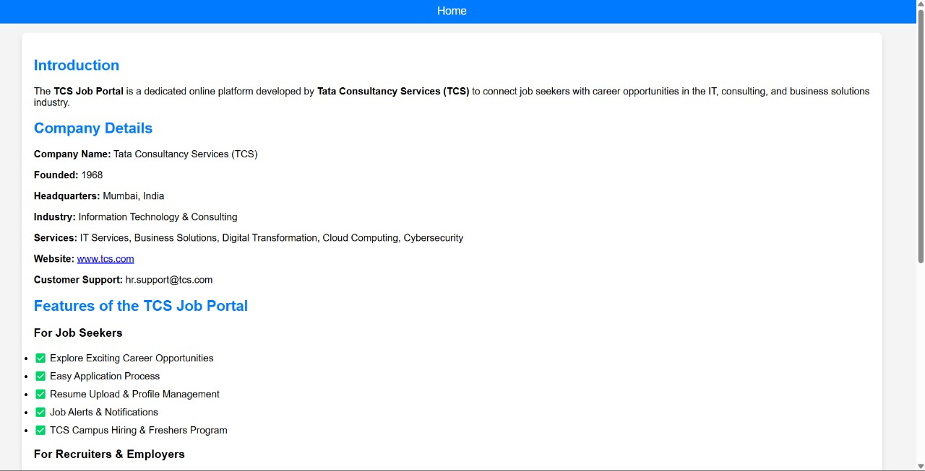

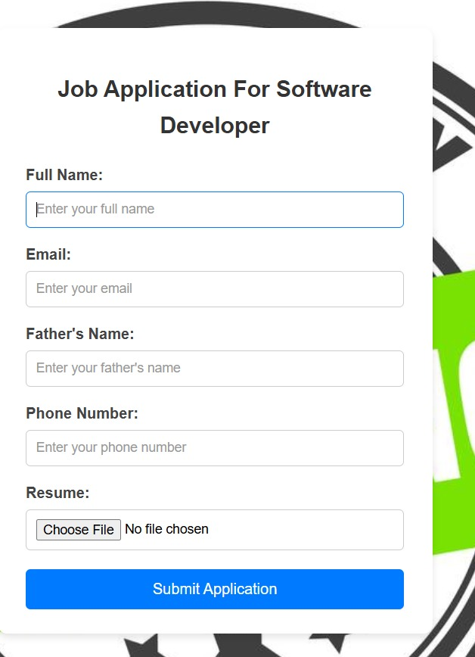

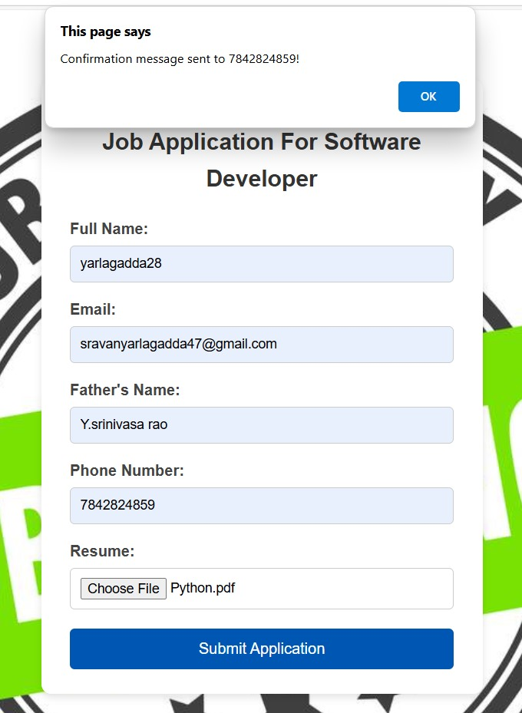

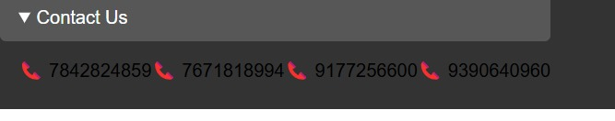

Conclusion

The Online Job Portal successfully overcomes the limitations of traditional job application processes by providing a secure, scalable, and efficient platform for connecting job seekers with employers. The system integrates user authentication, job management, application tracking, and result generation to streamline the recruitment process.

Key Achievements

- Automated Application Processing & Instant Feedback: Reduces the burden of manual application review by automating the process.

- Multi-Role User Management: Admins, employers, and job seekers have distinct functionalities, ensuring smooth system operations.

- Secure Authentication & Data Encryption: Protects sensitive information using hashed passwords and role-based access control.

- Scalability & Performance Optimization: Can handle multiple concurrent users without performance degradation.

- Accessibility & User-Friendly Interface: Designed to work efficiently even in low-internet environments, making it suitable for job seekers in remote areas.

Future Enhancements

- AI-Based Resume Screening: Integrating machine learning algorithms to automate resume screening and matching.

- Mobile Application Development: Extending the system for better accessibility on mobile devices.

- Integration with HR Management Systems (HRMS): To provide a more comprehensive recruitment experience.

This system improves efficiency, security, and accessibility, making it an ideal solution for employers, recruitment agencies, and job seekers.

7. References

1. IEEE Papers on E-recruitment and Online Job Portals
- IEEE Xplore Digital Library
2. Research on Secure Online Recruitment Systems
- Smith, J., & Brown, K. (2021). "Security Challenges in Online Recruitment." Journal of Information Security, 12(1), 1-10.
3. Database Optimization for Large-Scale Online Systems
- Gupta, R. (2020). High-Performance MySQL. O'Reilly Media.
4. Web Development & Security Standards
- MDN Web Docs: (file:///C:/Users/srava/OneDrive/Desktop/kumar.html#about)
5. Online Job Portal Best Practices
- Open Source Community Discussions on Recruitment Platforms & HR Tools

